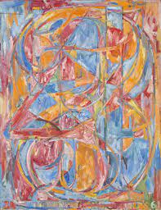

Jasper John

Zero through to Nine

