Wolsey House Primary School is committed to creating a happy and safe environment for our children to learn.

This leaflet will help you understand how we keep your children safe by telling you:

- How children can be harmed
- What we must do to keep you child safe from harm
- What you must do as a parent/carer to help your child be safe and enjoy school

Safeguarding Children and Child Protection

Child Protection is an important subject in which all staff receive regular training. Our priority is to work with you but there may be times when we have to involve other people. Everybody has a responsibility to keep all children under the age of 18 safe. Wolsey House Primary School has a statutory responsibility to share any concerns it may have about a child in need of protection with other agencies and in particular police, health and children’s services. Schools are not able to investigate concerns but have a legal duty to refer them.

In most instances, the school will be able to inform the parents/carer of its need to make a referral. However, sometimes the school is advised by children’s services or police that the parent/carer cannot be informed whilst they investigate the matter. We understand the anxiety parents/carers understandably feel when they are not told about any concerns from the outset. The school follows legislation that aims to act in the interests of the child.

Abuse / Harm is identified in four ways:

- Physical — Is when a child is deliberately hurt or injured
- Sexual — Is when a child is influenced or forced to take part in a sexual activity. This can be a physical activity or none physical, e.g. being made to look at an inappropriate image.
- Emotional — Is when a child is made to feel frightened worthless or unloved. It can be by shouting, using threats or making fun of someone. It can also be when children see their parents/carers, or visitors to the home, fighting or using violence
- Neglect — Is when a child is not being taken care of by their parents/carers. It can be poor hygiene, poor diet , not keeping appointments for additional support, not coming to school or being left home alone

It is advised that ALL parents/carers are familiar with our Child Protection and Safeguarding Policy which is available through our website and on request.

A child should be able to go to school and feel safe so that they can achieve their very best. Wolsey House will ensure:
- Anybody who works or volunteers at our school will have had the appropriate checks carried out to ensure that they are safe to work with children and then provided training to identify child abuse and what to do if they are concerned
- The school has a Designated Safeguarding Lead, Mr. Steve Powell, who has had extra training to know what to do when a concern is brought to him
- There are 6 other Designated Safeguarding Leads – please look at the website for further information
- That we always listen to you and work closely with you if we are concerned about your child but, sometimes, we may not be able to discuss our concern. The school has a safeguarding policy which tells you more about this and when we must speak to the police or children’s services. Please ask us about how you can see a copy of this policy
- We will help your child to learn about keeping themselves safe. Lessons can include healthy eating, anti‐bullying, e‐safety, road safety, healthy relationships, drug and alcohol awareness
- As part of these lessons and assemblies, your child will be told what to do if they are worried or concerned about their safety

What the parents/carers must do

Parents/carers are the most important people to keep their children safe. You should always:
- Feel confident to raise concerns about your child
- Feel confident to raise concerns about the conduct of a staff member/teacher
- Talk to school if you need help or support
- Read the school policies about safety issues available on request and on the schools website
- Let the school know if your child has a medical condition
- Let the school know if you have any court orders relating to the safety of your child
- Let the school know if there is a change in your circumstances such as a house move, a new contact number, a change of name, a change of parental responsibility
- Let the school know who will be dropping off or collecting your child and provide us with a total of three emergency contact names and numbers. You must inform the school of any changes to agreed arrangements
- Let the school know if your child is going to be absent and the reasons why

Safeguarding Issues

Attendance - Your child's attendance is monitored daily and significant absences are always followed up by the attendance officer. The school has an attendance policy that you should read and understand and at times, you may be asked to produce travel documents if you are taking your child out of school during term time or for other long periods of time.

Behaviour – Wolsey House has clear behaviour rules for the whole school community that must be followed to keep everyone safe and happy. We understand that children do sometimes fall out and this will be dealt with by an adult who will listen to the children involved and help resolve the situation.

Bullying - The school takes all cases of bullying very seriously and will work with children and families to try and resolve any problems. The school has an anti-bullying policy that you should read and understand.

Health and Safety - Everyone at Wolsey House has a responsibility to keep adults and children safe within the school environment. The school has a clear health and safety policy which everyone must follow. The school have fully trained first aiders to deal with any accidents in school.

E‐safety - The school recognises that technology plays an important role in the education of our children and is committed to safeguarding children in the virtual world. Parents/carers should be vigilant and ensure that their children are accessing age appropriate social media platforms including the use of video games which are not suitable for the child’s age. To support parents, the school has e‐safety information to help keep your children safe both at home and in school, which is available on our schools website and on request.

Complaints - If you have any complaints about how the school is working with you or your child please feel confident to speak to us. The Headteacher will always be happy to speak to you to resolve any difficulties. It is better to speak to us as soon as you have a concern so that it does not become a bigger issue. If you do not feel the matter has been resolved, you can raise your concerns with the Chair of Governors.
Useful Contacts
Headteacher Mrs Helen King

Designated Safeguarding Lead and deputies:
Steve Powell (DSL) Yasin Ismail
Helen King Ginny Southwell
Julie Cooper-Marsh Jacqueline Hayes
Emily Satchwell Leanne Watts
Steve Punchard Jim Baker
Chair of Governors
(With safeguarding responsibility) Mr. Matt Peatfield

Wolsey House Primary School
Beaumont Leys Lane, Leicester, LE4 2BB
01162 667 566
office@wolseyhouse.leicester.sch.uk

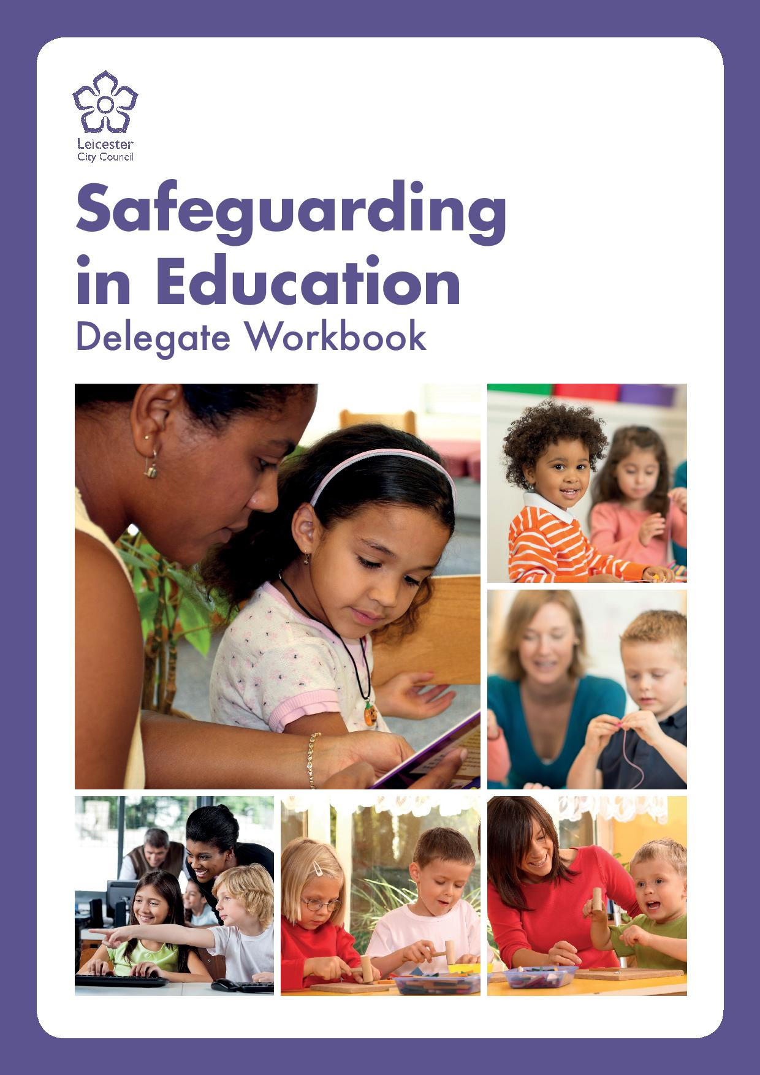

Keeping Children Safe in Education

Information for Parents/Carers

We ensure children learn in a safe, caring and enriching environment. Children are taught how to keep themselves safe, to develop positive and healthy relationships, and how to avoid situations where they might be at risk including by being exploited.

