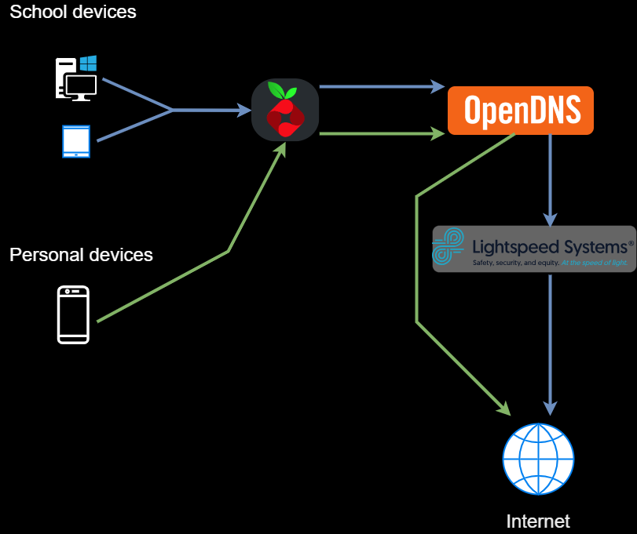
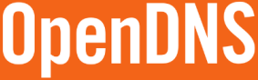

Pi-Hole Blocks domains that are in a list we provide. Our lists include Advert related domains and Suspicious domains that are known.

OpenDNS blocks domains that are categorised, we block domains that are in the following category:
Adware, Dating, Nudity, Pornography, Web spam, Adult Themes, Alcohol, Drugs, Gambling, Lingerie/Bikini, Sexuality, Tobacco, Advertisements, Anime/Manga/Webcomic, Games, Hate/Discrimination, Proxy/anonymizer, Tasteless and Weapons.
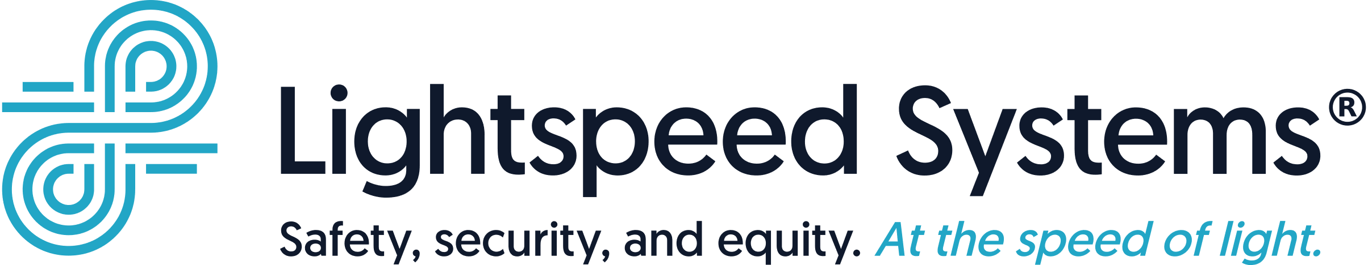
Light speed is a more sophisticated system that requires software installation on the PC’s allowing us to keep a closer eye on what is being searched and viewed on all pupil/staff devices. Lightspeed will block any websites, videos, images that contain inappropriate or mature content. Lightspeed uses a reporting system allowing DSL to access reports generated when a child accesses or searches for content blocked by us allowing us to act swiftly.

