Music Curriculum Overview 2025-2026
Years 1- 3:
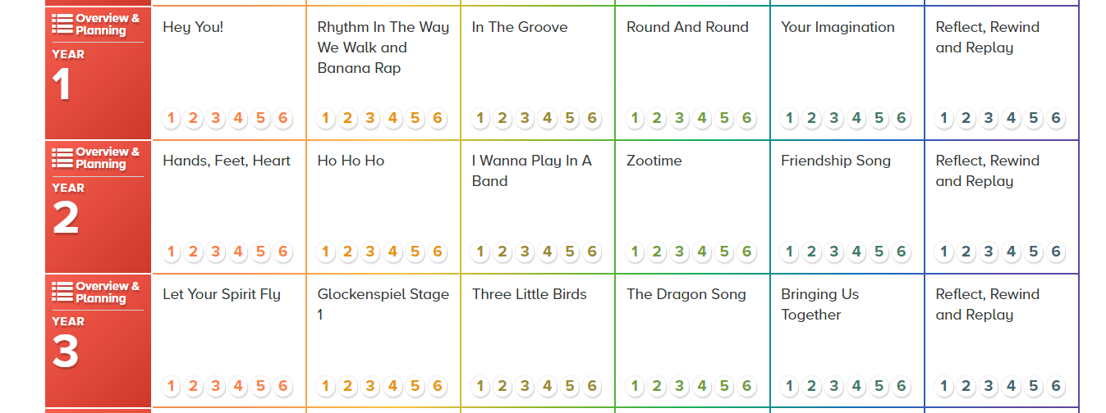
Years 4 & 5: Autumn and Spring Term – WCIT Scheme via Leicestershire Music then Charanga Music Scheme Summer 1 and 2
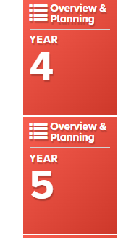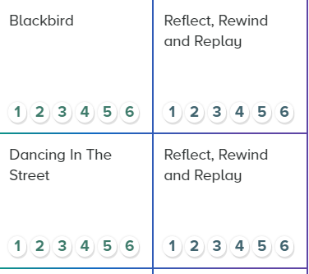
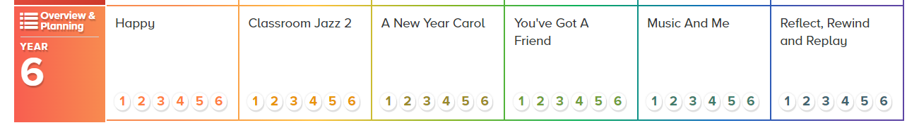

Foundation Stage:
Nursery:
In nursery we have music in our provision through nursery rhymes and number songs.
We also choose two songs from the school system and two independent songs that link with our topic to learn for the term. For example, last term we learnt the Pancake song on the school system and a rhyme called 999 999 (goes to Three Blind Mice) to match with our emergency services topic and that we were celebrating pancake day.
This term our topic is food! We are learning Ten Fat Sausages and the Picnic song from the school system.
Music is assessed through the phonic assessments.
We aim to plan in a musical instrument session on the carpet with the children every two weeks where we name the instruments: maraca, chime bar, tambourine, drum, two-tone block, claves and castanets.
We then play the instruments loudly, quietly, quickly, slowly and then sing the songs we have been practising to see who can keep the beat.

Foundation Stage: Reception:
Excerpt from Musical Development Matters in the Early Years:
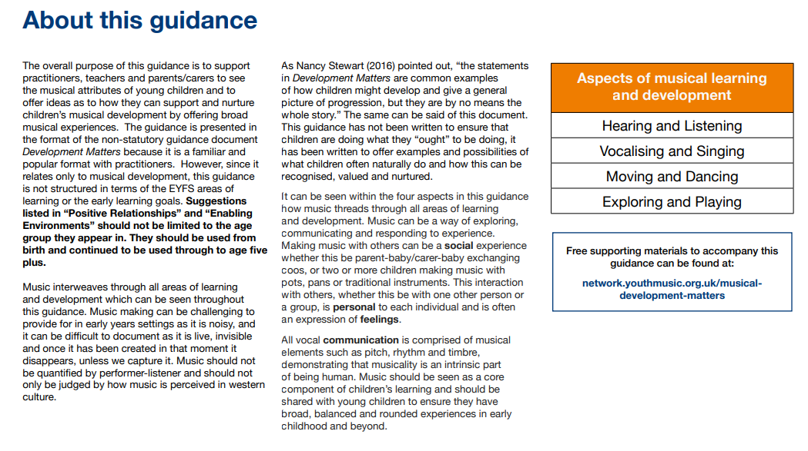
Bobby Shaftoe, clap your hands (is divided into 4 sections).
1: Actions, movement and imagination, 2:Exploring sounds, 3: Listening songs, 4: Making patterns
Teachers will plan and use a pick and mix system but always incorporate at least one element from each of the 4 sections in the music session. Elements will be noted each half term and then through teacher discretion elements will be repeated as appropriate.
There is a wide scope for differentiation within each element and this can also be built on as the year progresses.
An initial suggestion is that several elements are videoed so a record of progress is made.

