School Times

The school day for children in Reception to Year 6  starts at 8:55am  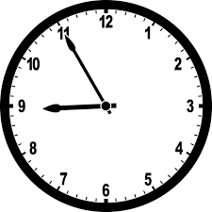 | School finishes at 3.15pm  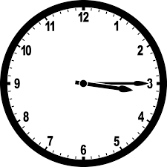
School uniform  For the whole school  Red or black jumper, cardigan or fleece. No hoodies  Grey or black trousers, skirt or pinafore dress  In the summer months a red and white gingham dress may be worn  Nursery, Reception, Years 1 and Year 2  Red or white polo shirt or white shirt or blouse  Years 3,4,5 and 6  White or Black polo shirt or white shirt or blouse  Suitable footwear must be worn. No Crocs  Jewellery  Stud earrings only. No necklaces or bracelets  Earrings will need to be taken out or covered with a plaster whilst doing PE | 
Uniform items with the school logo can be purchased from
https://myclothing.com

There is no requirement for children to wear uniform with the school’s logo on, but there is an expectation that the children wear school colours, i.e. red or black jumper. These can be bought from a range of shops e.g. Asda, Tesco.

Book Bags and PE Bags printed with the school logo can be purchased on the Parent Pay app and collected from the school office

PE Kit
Your child will need to come into school dressed in their PE kit on their PE day

Indoor: Red or white t-shirt, black shorts and plimsoles  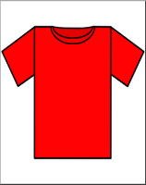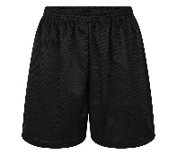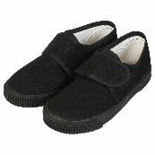 | Outdoor: Jogging bottoms, zip up jacket or sweatshirt and trainers. No hoodies  

