
Mathematics Policy
Wolsey House Primary School

HEADTEACHER: Mr Steven Powell
CHAIR OF GOVERNORS: MR M PEATFIELD

Date | Next review: | Subject Leader | Nominated Governor
04.07.25 | Summer 2026 | Yasin Ismail  Ranju Modhvadiya | Mrs Janette Shardlow

This policy is a working document that is fit for purpose, represents the school ethos, enables consistency and quality across the school and is related to the following legislation:

- Education Act 1996
- Education Act 1997
- Standards and Framework Act 1998
- Education (National Curriculum) Regulations 2000
- Education Act 2003
- Equality Act 2010

The following documentation is also related to this policy:

- The Education Inspection Framework (Ofsted 2019)
- An investigation into how to assess the quality of education through curriculum intent, implementation and impact (Ofsted 2018)
- Equality Act 2010: Advice for Schools (DfE)
- The National Curriculum in England Framework Document (DfE) 2014
- Race Disparity Audit - Summary Findings from the Ethnicity Facts and Figures Website (Cabinet Office)

We believe it is essential that this policy clearly identifies and outlines the roles and responsibilities of all those involved in the procedures and arrangements that is connected with this policy.

Aims

Our mathematics curriculum ensures that all pupils:
- Become fluent in the fundamentals of mathematics through consistent, meaningful practice.
- Reason mathematically using precise vocabulary, stem sentences, and effective representations.
- Solve increasingly complex problems with confidence and resilience.
- Develop a positive attitude towards mathematics and believe they can succeed.
- Experience inclusive, high ceiling, low threshold tasks that allow all children to achieve and deepen their learning.

The Essence of Mathematics Teaching for Mastery underpins lesson design and how mastery works in the classroom (NCETM).

Underpinning principles
- Mathematics teaching for mastery assumes everyone can learn and enjoy mathematics.
- Mathematical learning behaviours are developed such that pupils focus and engage fully as learners who reason and seek to make connections.
- Teachers continually develop their specialist knowledge for teaching mathematics, working collaboratively to refine and improve their teaching.
- Curriculum design ensures a coherent and detailed sequence of essential content to support sustained progression over time.
Lesson design
- Lesson design links to prior learning to ensure all can access the new learning and identifies carefully sequenced steps in progression to build secure understanding.
- Examples, representations and models are carefully selected to expose the structure of mathematical concepts and emphasise connections, enabling pupils to develop a deep knowledge of mathematics.
- Procedural fluency and conceptual understanding are developed in tandem because each supports the development of the other.
- It is recognised that practice is a vital part of learning, but the practice must be designed to both reinforce pupils’ procedural fluency and develop their conceptual understanding.
In the classroom
- Pupils are taught through whole-class interactive teaching, enabling all to master the concepts necessary for the next part of the curriculum sequence.
- In a typical lesson, the teacher leads back and forth interaction, including questioning, short tasks, explanation, demonstration, and discussion, enabling pupils to think, reason and apply their knowledge to solve problems.
- Precise mathematical language enables all pupils to communicate their reasoning and thinking effectively.
- If a pupil fails to grasp a concept or procedure, this is identified quickly, and gaps in understanding are addressed systematically to prevent them falling behind.
- Time is spent developing deep understanding of the key ideas that are needed to underpin future learning.
- Key number facts are learnt to automaticity, and other key mathematical facts are learned deeply and practised regularly, to avoid cognitive overload in working memory and enable pupils to focus on new learning.

Introduction

At Wolsey House Primary School, we believe mathematics is a creative, interconnected discipline essential for understanding the world and solving real-life problems. Through a carefully sequenced curriculum and inclusive teaching practices, we aim to develop confident, fluent mathematicians who enjoy reasoning, problem-solving, and collaborative learning.
This policy is a live document that reflects our current best practice, is adapted to meet the needs of our pupils, and is continually reviewed to ensure it remains relevant and effective.

Intent, Implementation and Impact

Intent
Our intent is to provide a mathematics curriculum that is coherently planned and carefully sequenced to enable children to develop sufficient knowledge and skills that will prepare them for future learning and employment. We aim for children’s maths books to demonstrate a clear progression of skills and strategies over time, in line with the Ready to Progress criteria. Children will confidently demonstrate and explain how to reason mathematically and how to solve problems using appropriate methods. They will also develop secure mental recall of multiplication and division facts, which will support them in solving arithmetic problems efficiently. At Wolsey House, we encourage children to work collaboratively, share their mathematical thinking, and challenge each other when solving problems and completing set activities. A key focus of our intent is to ensure that girls make strong and sustained progress across the school, so that more girls achieve the national expected standard in mathematics.

Implementation
We implement our mathematics curriculum using the White Rose Scheme of Work, which provides a progressive and challenging sequence of learning. However, we do not follow this rigidly and teachers are encouraged to use additional high-quality resources that meet the needs of their pupils. Lessons are structured using the NCETM Five Big Ideas and follow our established format: Hinge question, I do, we do, you do, followed by three stations – Maths Talk, Reasoning, and Problem Solving. Teachers provide regular verbal feedback so that children understand their next steps and how to improve. Throughout the school, children are encouraged to use concrete, pictorial, and abstract representations to demonstrate their thinking and understanding Sentence stems are provided every lesson to support children’s reasoning and oracy. We use Times Tables Rock Stars, Fluency Bee, arithmetic tests, and our Times Tables Challenge to build a strong foundation in number sense, arithmetic, and multiplication knowledge. Teachers and pupils consistently use accurate mathematical vocabulary and build a shared bank of stem sentences to support reasoning and explanation. Additionally, Boost Insights gap analysis is used to quickly identify learning gaps, which allows teachers to address misconceptions and tailor support promptly.

Impact
The impact of our mathematics curriculum is that children at Wolsey House are becoming increasingly proficient in using mental arithmetic strategies to solve a wide range of mathematical problems. Pupils are confident and resilient when explaining and demonstrating their problem-solving approaches, showing that they can articulate their reasoning clearly. Children display highly positive attitudes towards collaborative problem solving and are keen to work with their peers to share strategies and discuss solutions. The attainment gap between boys and girls is steadily closing, with girls now making improved progress, largely supported by the consistent use of the CPA approach. Across the school, children are showing deeper understanding by representing problems in different ways and by revisiting and solving the same questions from alternative perspectives. Pupils are demonstrating increasing confidence, independence, and flexibility in their mathematical thinking.
We follow the White Rose Maths long-term plan, which is carefully structured to provide small, progressive steps in learning. White Rose Maths builds deep understanding by revisiting concepts regularly and making strong connections between topics. The scheme promotes the CPA approach and incorporates reasoning and problem-solving opportunities throughout. It provides well-sequenced lessons, clear models, and varied fluency practice to support all learners. We use the White Rose resources flexibly to meet the needs of our children, prioritising Ready to Progress lessons to secure key knowledge and address learning gaps as they arise.
We assess and monitor mathematics through a range of ongoing strategies. Weekly arithmetic and times tables tests are used to regularly assess fluency. End of unit retrieval clocks and Blooket quizzes are used to identify gaps immediately so they can be addressed in subsequent lessons and inform future planning. We use diagnostic and end of term Rising Stars assessments, which produce detailed gap analyses through Boost Insights to guide future teaching. Formative assessment is ongoing and used throughout every lesson to check understanding and adapt teaching in real time. We conduct book looks with children to assess retrieval, performance, and long-term learning over time. Standards are further monitored through learning walks, pupil voice, and book moderations to ensure consistency and progress across the school.

Teaching and Learning Style

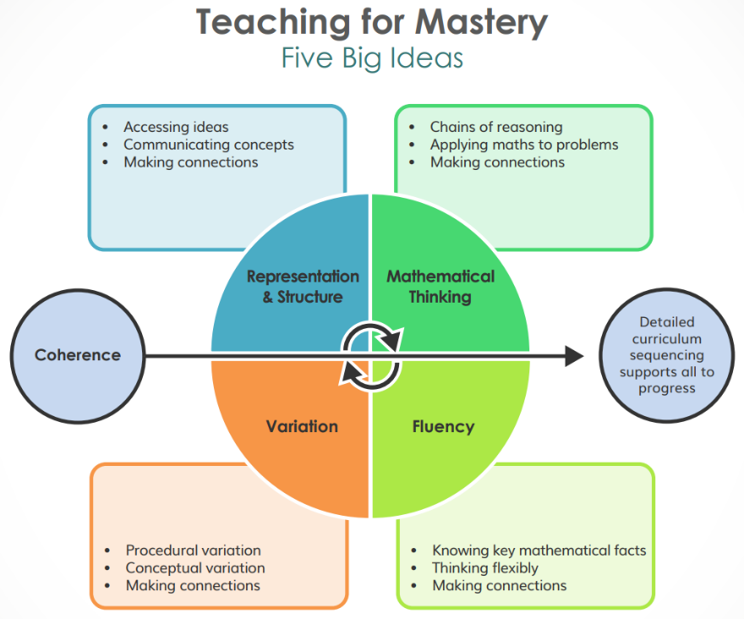
We use a variety of teaching and learning styles in order to develop children's knowledge, skills and understanding. The 5 big ideas are the fundamental characteristics that underpin our teaching for mastery mathematics curriculum. These include: representation and structure, mathematical thinking, variation, fluency and coherence.

The maths lead (Yasin Ismail) delivered TRGs (Teacher research group meetings) to all teachers and the SLT as part of their continual professional development. This was/is followed up with maths learning walks to ensure that these approaches were/are evident in all mathematical teaching at our school.
We ensure that every teacher has a clear understanding of the calculations policy.

Coherence
Teaching is designed to enable a coherent learning progression through the curriculum, providing access for all pupils to develop a deep and connected understanding of mathematics that they can apply and communicate in a range of contexts.

Representation and Structure
Teachers carefully select representations of mathematics to expose mathematical structure. The intention is to support pupils in ‘seeing’ the mathematics, rather than using the representation as a tool to ‘do’ the mathematics. These representations become mental images that students can use to think about and discuss mathematics, supporting them to achieve a deep understanding of mathematical structures and connections.

Mathematical Thinking
Mathematical Thinking is central to how pupils learn mathematics and includes looking for patterns and relationships, making connections, conjecturing, reasoning, and generalising. Pupils should actively engage in mathematical thinking in all lessons, discussing and communicating their ideas using precise mathematical language.

Fluency
Efficient, accurate recall of key number facts and procedures is essential for fluency, freeing pupils’ minds to think deeply about concepts and problems, but fluency demands more than this. It requires pupils to have the flexibility to move between different contexts and representations of mathematics, to recognise relationships and make connections, to explain their ideas and to choose appropriate methods and strategies to solve problems.
Variation

The purpose of variation is to draw closer attention to a key feature of a mathematical concept or structure through varying some elements while keeping others constant. Through variation the teacher focuses thinking and discussion on the key feature in question.
- Conceptual variation involves varying how a concept is represented to draw attention to critical features. Often more than one representation is required to look at the concept from different perspectives and gain comprehensive knowledge.
- Procedural variation considers how the student will ‘proceed’ through a learning sequence. Purposeful changes are made in order that pupils’ attention is drawn to key features of the mathematics, scaffolding students’ thinking to enable them to reason logically and make connections.

Mathematics lessons at Wolsey House follow a consistent structure to maximise learning, promote retention, and foster reasoning skills.
Daily Lesson Structure

EYFS
Maths in the Early Years focuses on developing early number sense and mathematical thinking through a combination of direct teaching and well-planned provision.
Teachers introduce key mathematical ideas through short whole-class inputs. After that, children move into continuous provision where those ideas are explored through carefully planned activities and resources.
Adults work with small groups for focused teaching but they also interact with children in the provision to extend their mathematical thinking — for example through counting, comparing quantities, noticing patterns or talking about shape and measure.
Planning is guided by the Early Years Framework and supported by Development Matters but staff focus on building deep understanding of number, particularly through subitising, counting and composition of number, which is done through maths teaching as well as a bespoke Number Ninjas programme.
Assessment is ongoing through observation and interactions, and by the end of Reception teachers use the evidence they have gathered to judge whether children have achieved the Maths Early Learning Goals.

Key Stage 1
1. Hinge question: this acts as a quick diagnostic which will inform how the rest of the lesson will play out, e.g. If the learning intention was to do with comparing whether an object is longer or shorter than another object, the hinge question might be, ‘Stick A is longer than stick B. True or false?’
2. Teacher Input (10-15 minutes) – I do, we do, you do:
Example:
- I do: Teacher models how to solve a division with remainders using base ten.
- We do: Teacher and pupils solve a similar division problem together, sharing thinking.
- You do: Pupils independently solve a related division problem, with the teacher circulating to check understanding.
3. Three Stations:
- Maths Talk (this is a teacher-led group focusing on reasoning or problem-solving)
- Reasoning or Problem Solving (children work independently to solve a reasoning or problem solving question)
- Foundational knowledge (children work independently on foundational knowledge skills. These might include number formation, one to one correspondence, subitising, etc…)

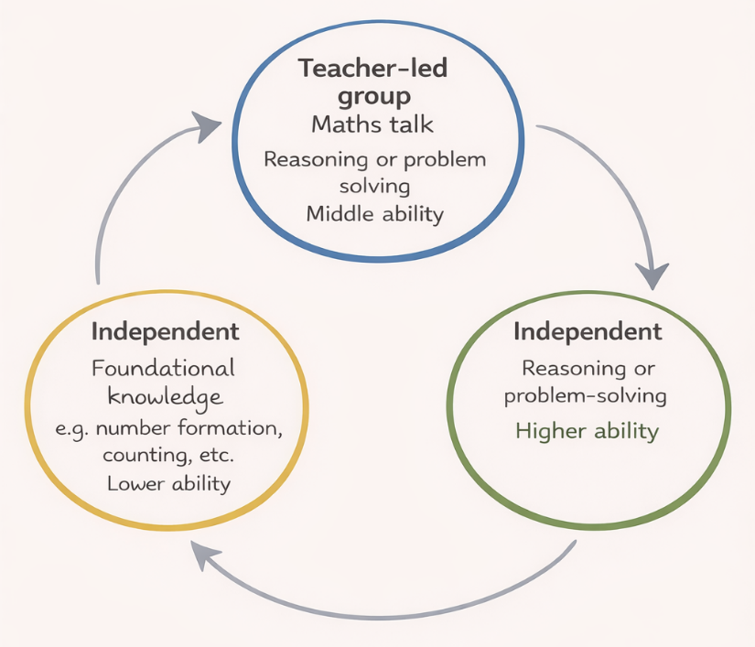

Key Stage 2
1. Hinge question: this acts as a quick diagnostic which will inform how the rest of the lesson will play out, e.g. If the learning intention was to do with flexible partitioning in year 4, the hinge question might be, ‘2478 = 1000 + 1400 + 70 + 8. True or false?
2. Teacher Input (15 minutes) – I do, we do, you do:
Example:
- I do: Teacher models how to solve a division with remainders using base ten.
- We do: Teacher and pupils solve a similar division problem together, sharing thinking.
- You do: Pupils independently solve a related division problem, with the teacher circulating to check understanding.
3. Three Stations:
- Maths Talk
- Reasoning
- Problem Solving

Maths Talk, Reasoning, and Problem Solving: What’s the Difference?

Maths Talk: Focuses on explaining, discussing, and articulating mathematical ideas.
Example: "Explain why 5 + 5 + 5 is the same as 3 x 5."
Importance: Builds vocabulary, confidence, and collaborative learning.
This station is teacher led.
Reasoning: Focuses on using logic, identifying patterns, justifying answers, and making connections.
Example: "True or false: If 240 ÷ 4 = 60, then 24 ÷ 4 = 6. Explain your answer."
Importance: Deepens conceptual understanding and strengthens logical thinking.
Problem Solving: Focuses on applying strategies to tackle unfamiliar, often multi-step problems.
Example: "I have 10kg of flour. Each cake uses 3.5kg. How many cakes can I make?"
Importance: Builds resilience, flexible thinking, and real-world problem-solving skills.
All three are essential to develop fluent, confident, and independent mathematicians.

Adaptive teaching and differentiation
At Wolsey House Primary School, we understand the difference and see the value in both differentiation and adaptive teaching. Below is a brief outline of what each one involves:

Differentiation:
- Changing the composite and component parts for a child or small group of children who are working at a level well below age expected.
- Individualised learning plans
- Mini lessons for different groups of learners
- Separate provisions/interventions
- These children have a different ‘end goal’ to the majority of the class.

Adaptive teaching:
- One lesson for all children where the composite and component parts remain the same.
- Identifying children who might be struggling in the moment and providing additional scaffolds so that they can meet the same end goal.
- Provides a supportive and inclusive learning environment
- Provides appropriate challenges and support
- Encourages children to ‘keep up’ not ‘catch up’

We believe we have a duty to ensure that all children have equal rights to the opportunities offered by education and that all children will be encouraged to fulfil their potential in their academic, physical and creative achievements.

We want to give all children the right to access high quality educational experiences, to take part in a broad and balanced curriculum and to be part of the social life of the school.

We have an obligation to plan and deliver well-structured lessons with appropriate assessment plus ambitious targets for pupils who have low levels of prior attainment or come from disadvantaged backgrounds.

Also, we have a duty to cater for pupils whose first language is not English by planning teaching opportunities to help them develop their English and to gain full access to the National Curriculum.

Curriculum Planning and Organisation

We follow the White Rose Maths long-term plan, adapted to prioritise Ready to Progress lessons, meet the needs of our children, and use White Rose resources flexibly rather than rigidly.
Teachers collaborate on the planning of the subject to ensure parity in provision and to share expertise. Curriculum planning is managed in three phases namely:

Long Term Planning (Lesson by lesson overviews/ready to progress criteria)

- details what is to be taught over the year
- provides teaching guidelines and overall objectives for each year group for the whole year

Medium Term Planning (Lesson by lesson overviews/ready to progress criteria)

- organises the subject into termly or half-termly sections
- is more detailed and the objectives are more specific in nature
- is developed by the teachers, who respond to the needs of their pupils
- ensures a balanced distribution of work is undertaken across each term

Short Term Planning (Schemes of Learning documents)

- details the subject curriculum over the week
- plans lessons in detail with specific class objectives
- sets individual learning goals for each pupil

Special Educational Needs and Inclusion

Inclusion
Mathematics at Wolsey House is fully inclusive:
- Lessons are accessible to all pupils.
- Tasks offer multiple entry points and encourage independence.
- Scaffolding is provided where necessary to support success.
- Pupils with SEND and those with low prior attainment are fully supported to access and succeed within the full mathematics curriculum.

High Ceiling, Low Threshold Activities
All pupils engage with high ceiling, low threshold tasks, which:
- Are accessible to all pupils, with multiple entry points.
- Offer opportunities for deep thinking and challenge.
- Promote inclusion by allowing children to work at a level that stretches them, regardless of prior attainment.
Example: Task: Find as many ways as possible to make 24 using addition, subtraction, multiplication, and division.
- Low Threshold: Pupils may begin with simple facts such as 20 + 4 or 12 + 12.
- High Ceiling: Pupils may explore complex solutions like (6 x 8) ÷ 2 or use negative numbers, fractions, or brackets.
These tasks ensure all pupils can participate meaningfully and are fully supported to succeed.

Times tables and fluency development

Fluency Development
Foundation Stage: Pupils follow a bespoke fluency programme called Number Ninjas, inspired by Number Sense, focusing on subitising, one more/one less, and early counting patterns.
Year 1 to Year 4: Daily Fluency Bee sessions build rapid recall of number bonds, doubles, halves, and multiplication/division facts.
Year 5 and Year 6: Pupils spend 10 minutes daily practising the four operations to maintain fluency and strengthen arithmetic strategies.

Times Tables Challenge
Children in Years 2–6 participate in the Times Tables Challenge with progressive stages:
- Bronze: 2, 5, 10 times tables
- Silver: 2, 3, 5, 10 times tables
- Gold: 2, 3, 4, 5, 6, 7, 8 times tables
- Platinum: Up to 11 times tables
- Diamond: All facts to 12 x 12, including division
- Lightning: Decimal multiplication and x10/x100 facts
- Mr Ismail McSpecial: Decimals, percentages, negative numbers, fractions, squares, cubes
Rewards:
- Autumn Term: Movie Morning
- Spring Term: Chocolate Egg
- Summer Term: Trip to Abbey Park
Certificates and rewards celebrate sustained effort and achievement.

Assessment for Learning

Teachers will:

- carry out formative assessment in the form of informal observations of pupils
- mark books and give verbal or whole class feedback
- carry out end of unit tests
- carry out end of term assessments
- use gap analysis and other data to inform and edit planning
- administer national tests and assessment in Y2 and Y6;
- carry out tests at the end of Y3, Y4 and Y5;
- use long-term assessments to help them plan for the next academic year;
- inform parents and carers of their child's progress and targets.

Monitoring and Review of the Subject

Monitoring of standards of children's work and the quality of teaching is the responsibility of the subject coordinator supported by the Headteacher and the SLT.

Standards will be monitored by:

- looking at pupils work
- subject observations and/or learning walks
- pupil discussions
- audit of subjects
- general curriculum discussions

Role of the Governing Body

The Governing Body has:

- appointed a member of staff to be responsible for the curriculum leadership of Mathematics;
- delegated powers and responsibilities to the Headteacher to ensure all school personnel and stakeholders are aware of and comply with this policy;
- responsibility for ensuring compliance with the legal requirements of the National Curriculum;
- responsibility for ensuring that the school complies with all equalities legislation;
- responsibility for ensuring funding is in place to support this policy;
- responsibility for ensuring this policy and all linked policies are maintained and updated regularly;
- responsibility for ensuring all policies are made available to parents;
- responsibility for the effective implementation, monitoring and evaluation of this policy.

Role of the Headteacher

The Headteacher will:

- work in conjunction with the Senior Leadership Team to ensure all school personnel, pupils and parents are aware of and comply with this policy;
- ensure teachers:
- ‘have good knowledge of the subject(s) and courses they teach;
- have effective support for those teaching outside their main areas of expertise;
- present subject matter clearly, promoting appropriate discussion about the subject matter they are teaching;
- check learners’ understanding systematically, identify misconceptions accurately and provide clear, direct feedback and in doing so, they respond and adapt their teaching as necessary.
- design their teaching to help learners to remember in the long term the content they have been taught and to integrate new knowledge into larger concepts;
- use assessment well in order to help learners embed and use knowledge fluently or to check understanding and inform teaching;
- create an environment that allows the learner to focus on learning;

(Amended from the ‘Education Inspection Framework’ (Ofsted 2019)

Role of the Subject Leader

The Subject Leader will:

- lead the development of this policy throughout the school;
- work closely with the Headteacher, curriculum leader, the nominated governor and SENCO;
- promote the teaching of numeracy within all subjects;
- be accountable for standards in this subject area;
- monitor standards by:

- auditing the subject area
- review of the scheme of work
- lesson observations and learning walks
- scrutinising children's work
- discussions with pupils

- work in conjunction with the Headteacher, Senior Leadership Team, the Curriculum Leader, Subject Leaders, teaching and support personnel to provide statements on each of the following:
- ensure continuity and progression throughout the school;
- devise a subject improvement plan;
- provide guidance and support to all staff;
- provide training for all staff on induction and when the need arises regarding;
- attend appropriate and relevant INSET;
- keep up to date with new developments;
- undertake an annual audit and stock take of resources;
- purchase new resources when required and in preparation for the new academic year;
- manage the subject budget effectively;
- undertake risk assessments when required;
- review and monitor;
- annually report to the Governing Body on the success and development of this policy.

Role of Teachers

Teachers will:

- comply with all aspects of this policy;
- work closely with the subject leader to develop this policy;
- devise medium and short term planning;
- develop mathematical fluency, numeracy and mathematical understanding in all subjects;
- plan and deliver good to outstanding lessons;
- plan lessons which are interactive, engaging and of a good pace;
- have high expectations for all children and will provide work that will extend them;
- assess, record and report on the development, progress and attainment of pupils;
- achieve high standards;
- celebrate the success of pupils in lessons
- implement the school’s equalities policy and schemes;
- report and deal with all incidents of discrimination;
- attend appropriate training sessions on equality;
- report any concerns they have on any aspect of the school community.

Role of Pupils

Pupils will:

- be aware of and comply with this policy;
- be encouraged to work in partnership with the school by making decisions and exercising choice in relation to their educational programme;
- listen carefully to all instructions given by the teacher;
- ask for further help if they do not understand;
- participate fully in all lessons;
- participate in discussions concerning progress and attainment;
- treat others, their work and equipment with respect;
- support the school Code of Conduct and guidance necessary to ensure the smooth running of the school;
- liaise with the school council;
- take part in questionnaires and surveys.

Role of Parents/Carers

Parents/carers will:

- be aware of and comply with this policy;
- be encouraged to take an active role in the life of the school by attending:

- parents and open evenings
- parent-teacher consultations
- curriculum development workshops

- be encouraged to respond to curriculum information newsletter;
- be informed via termly newsletters of their child’s topics;
- asked to provide suggestions and ideas for improving this subject;
- be asked to take part periodic surveys conducted by the school on curriculum development;
- encourage effort and achievement;
- encourage completion of homework and return it to school;
- provide the right conditions for homework to take place;
- expect their child to hand in homework on time;
- join the school in celebrating success of their child's learning.

Contribution of the Subject to other Areas of the Curriculum

Mathematics contributes to many subjects within the primary curriculum and opportunities will be sought to draw mathematical experience out of a wide range of activities. This will allow children to begin to use and apply mathematics in real contexts.

Resources

The school has a full range of resources to support the teaching of this subject throughout all year groups. Resources are upgraded and replenished when the need arises. An annual stock take and audit is undertaken by the subject coordinator in the summer term in preparation for the next academic year.

Raising Awareness of this Policy

We will raise awareness of this policy via:

- School Handbook/Prospectus;
- School website;
- Staff Handbook;
- Meetings with parents such as introductory, transition, parent-teacher consultations
- School events;
- Meetings with school personnel;
- Written communications with home such as weekly newsletters and of end of half term newsletters;
- Annual report to parents;
- Headteacher reports to the Governing Body;
- Information displays in the main school entrance;
- Text messages
- Email
- Social media: e.g. Twitter

Training

All school personnel:

- have equal chances of training, career development and promotion
- receive training on this policy on induction which specifically covers:

- National Curriculum programmes of study and attainment targets for all subjects
- Curriculum
- Teaching and learning
- Planning
- Assessment
- Monitoring and Evaluation
- Special Educational Needs
- Academically More Able Pupils
- Key skills

Equality Impact Assessment

Under the Equality Act 2010 we have a duty not to discriminate against people on the basis of their age, disability, gender, gender identity, pregnancy or maternity, race, religion or belief and sexual orientation.

This policy has been equality impact assessed and we believe that it is in line with the Equality Act 2010 as it is fair, it does not prioritise or disadvantage any pupil and it helps to promote equality at this school.

Headteacher: |  | Date:
Chair of Governing Body: |  | Date:

