Year 1
Autumn 1 | Autumn 2 | Spring 1 | Spring 2 | Summer 1 | Summer 2
The Naughty Bus by Jan and Jerry Oke    Introduce colourful semantics.  (Who? & What like?)  Description using simple sentences  Colourful semantics  (Who, what doing, what?)  Write sentences in the past tense.  Write a recount. | The Queen’s Handbag by Steve Antony  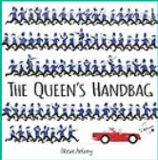  To write sentences using proper nouns from the story.  To write sentences/ captions based on our pre teach prefix words un.  To write questions using, who, what, where,  when and how.  To write questions using wh questions independently  To Write simple sentences using ‘and’  To write a recount  To make own sentences using colourful semantics with the sequence  Who  What  Doing | Paddington Bear by Michael Bond    To use expanded noun phrases to describe Paddington bear  To use colourful semantics adding the box ‘where’ to extended sentences.  To write a recount on what happened in the Paddington bear story.  Retell story to parents at home.  To write simple sentences using es and s. | How does an egg hatch by  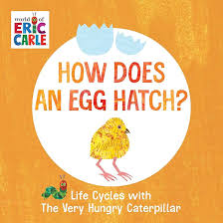  Write a daily recount on what the chicks are doing  Write a recount on the life cycle of a chick from first-hand experience.  Fact file-  Appearance & habitat  - Fact file-  Diet & Fun facts | Lost and Found by Oliver Jeffers  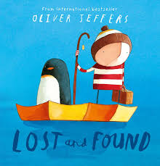  Recount- To inform people of where the teddy was found and where it belonged.  Write a character description about themselves.  Retell a story - To inform people of how the penguin got back home.  Questions – To write questions about Lost and Found | The Tiger who came to tea by Judith Kerr    Write a character description of the tiger.  Write an invitation for a tea party.  Write lists of what items you would have at the tea party.  Write a recount of the family’s day tea party.

