Year 2
Autumn 1 | Autumn 2 | Spring 1 | Spring 2 | Summer 1 | Summer 2
Beegu by Alexis Deacon  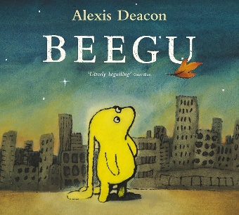  Character description of Beegu  Character description of man  Setting description of the city  Giving Beegu choices of what can do see and do in the city.  Reunion of Beegu with her parents and the questions they ask.  Recount of Beegu’s adventures on earth | The Day the Crayons Quit by  Oliver Jeffers  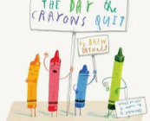  Recount of The Great Fire of London  Recount Toby’s actions in the story  Write a list of objects Toby took with him when he left the house  To write a letter to Duncan from Red Crayon’s POW  To write a letter from Duncan to Red Crayon  To write sentences using conjunctions ‘so and ‘because’ | 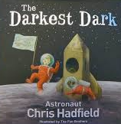  The Darkest Dark by Chris Hadfield  Recount for the first part of the story using ‘when’  Setting description of Chris’s bedroom using possessive apostrophe  Narrative of Chris’s dream  Recount of watching the moon landing.  Chronological report about Neil Armstron | Mog in the Dark by Judith Kerr  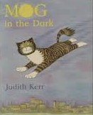  Narrative of the first part of the story  Narrative of the next part of the story  Narrative of the last part of the story  Types of sentences – statements, commands and questions | The Flower by John Laight  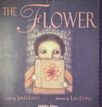  Character description of Brigg  Setting description of the city  Description of the shop  Suggestion of how the city could be improved  description of the city at the end of the story | The Tear Thief by Carol Ann Duffy  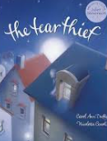  Character description of the tear thief  Narrative of the middle of the story  Setting description of the night time setting.  Narrative of a new adventure of the tear thief visiting another place.

