Year 3
Autumn 1 | Autumn 2 | Spring 1 | Spring 2 | Summer 1 | Summer 2
The Tin Forest by Helen Ward and Wayne Anderson  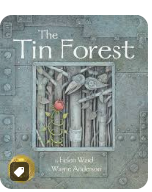  Setting Description  Character Description  Non-Chronological Report | The Wolf’s Secret by Myriam Dahman and Nicolas Digard  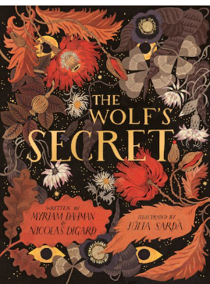  Setting Description  Character Description  Recount | The Golden Cage by Anna Castagnoli, Carli Cneut et al.  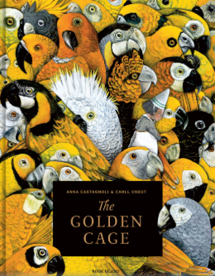  Character Description  Dialogue  Narrative – Alternative Ending | The Stone Age Boy by Satoshi Kitamura  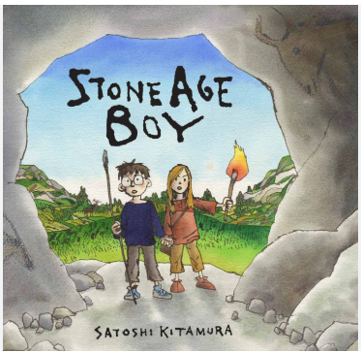  Character Description  Dialogue  Non-Chronological Report | Leon and the Place Between by Angela McAllister and Grahame Baker-Smith  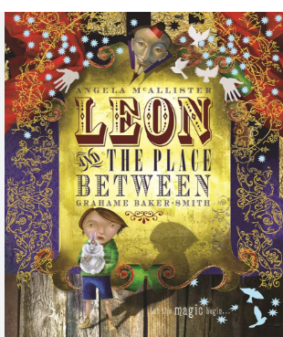  Setting Description  Recount  Dialogue | The Wild Robot by Peter Brown  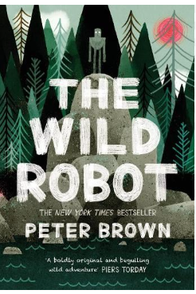  Character Description  Setting Description  Narrative

