Year 5
Autumn 1 | Autumn 2 | Spring 1 | Spring 2 | Summer 1 | Summer 2
The Magic Box by Kit Wright  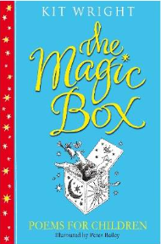  Character description  Poem  Setting description | The Iron Man by Ted Hughes  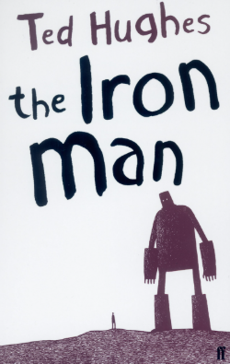  Character description  Non-chronological report  Letter  Writing based on rainforest deforestation  Non-chronological report  Setting description  Formal Speech | Harry Potter and the Philosopher’s Stone by J.K. Rowling  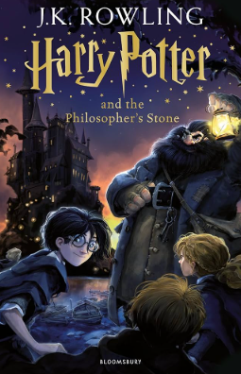  Dialogue  Narrative (adaptation of Harry of Potter) | Farther by Grahame Baker-Smith  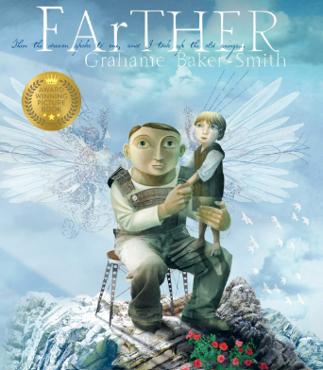  Description  News script  Narrative | Goodnight Mr Tom by Michelle Magorian  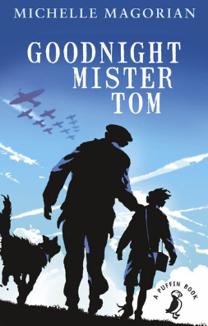  Character description  Diary from two perspectives  Character description  Diary from two perspectives | The Wolf Wilder by Katherine Rundell  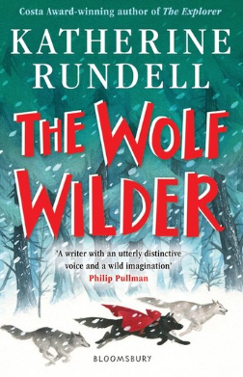  Setting description  Wolf description  Narrative  Writing based on The Legend of Tutankhamun  Biography  Newspaper article

