Year 6
Autumn 1 | Autumn 2 | Spring 1 | Spring 2 | Summer 1 | Summer 2
Holes by Louis Sacher  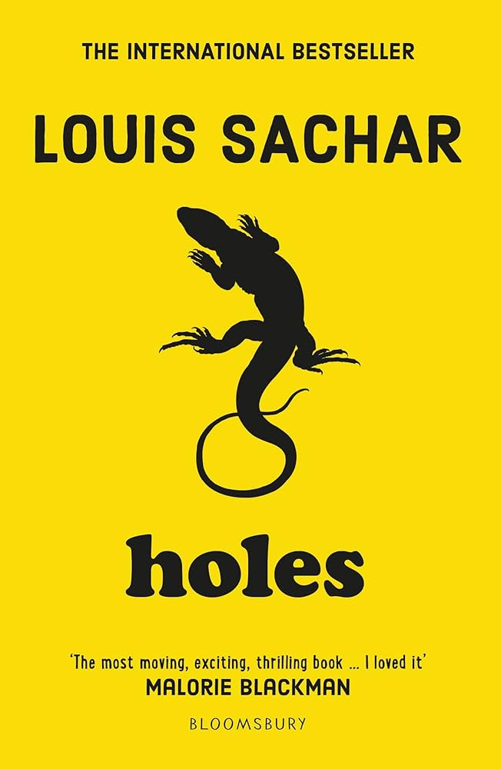  Setting Description  Letter  Diary entry  Non-Chronological Report  Integrate dialogue using EAST | Wonder by R J Palacio    Diary entry  Dialogue  Retell an event from a different character’s POV  Narrative  Informal Letter  Formal letter | Floodland by Markus Sedgwick  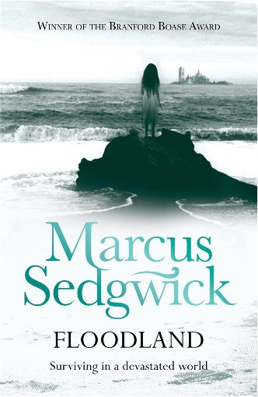  Setting description  Diary entry  Message in a bottle  Dialogue using EAST | Skellig by David Almond  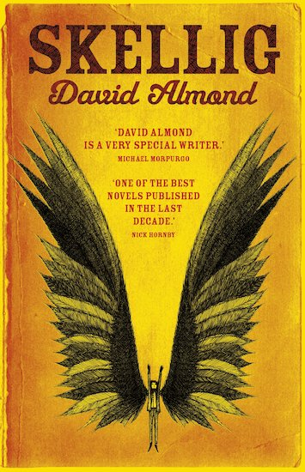  Setting description with dialogue  Retell an event from a different character’s POV  Letter  Diary | The Man who Walked Between the Towers by Mordecai Gerstein  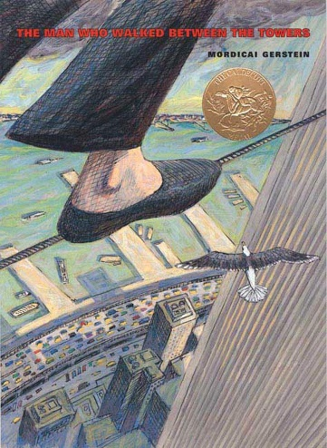  Non-Chronological report  Setting description  Narrative  Recount  Newspaper report | The Boy at the Back of the class by Onjali Rauf  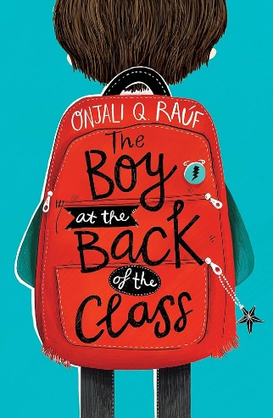  Newspaper report  Instructions  Recount  Letter  Diary

